Topalian
JavaScript
Text Editor
by
Christopher Andrew Topalian

All Rights Reserved
Copyright 2000-2024
Dedicated
to
God the Father

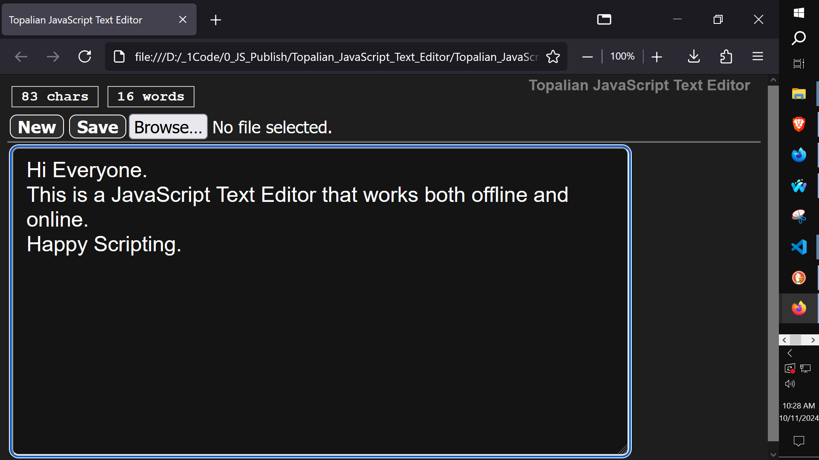
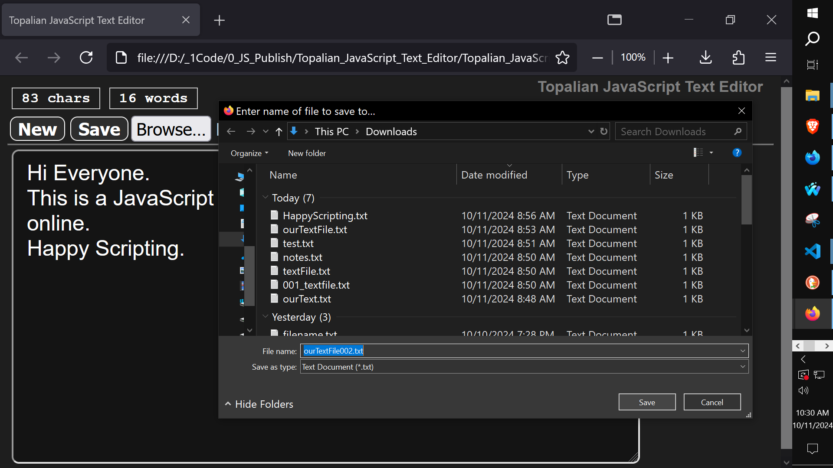
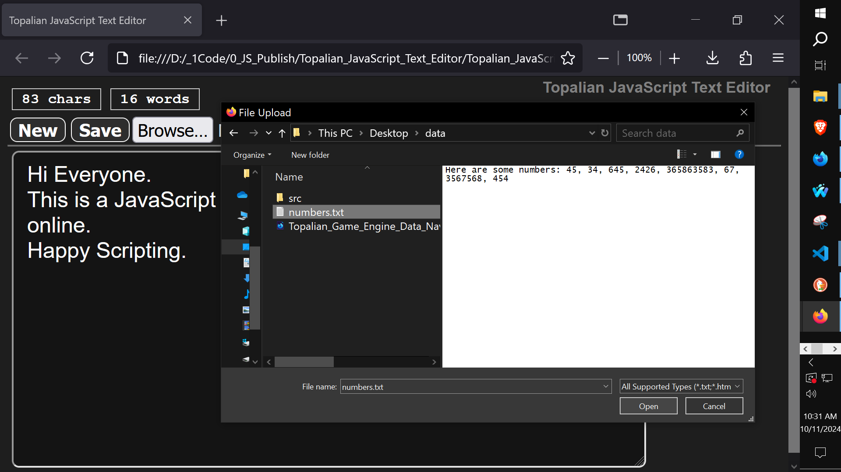
<!-- Dedicated to God the Father -->
<!-- All Rights Reserved Christopher Andrew Topalian Copyright 2000-2024 -->
<!-- https://github.com/ChristopherTopalian -->
<!-- https://github.com/ChristopherAndrewTopalian -->
<!-- Topalian_JavaScript_Text_Editor_(Online_Version).html -->
<!-- Version 001 - (2024-10-11) -->

<html>
<head>
<title> Topalian JavaScript Text Editor </title>

<style>

/* style001.css */

body
{
background-color: rgb(30, 30, 30);
font-family: Arial;
font-size: 24px;
color: rgb(255, 255, 255);
}

textarea
{
width: 700px;
height: 350px;
margin: 5px;
padding-left: 15px;
padding-right: 15px;
padding-top: 10px;
padding-bottom: 10px;
background-color: rgb(20, 20, 20);
font-family: Arial;
font-size: 24px;
color: rgb(255, 255, 255);
}

hr
{
margin: 0px;
}

button
{
margin: 3px;
padding-left: 8px;
padding-right: 8px;
padding-top: 1px;
padding-bottom: 1px;
background-color: rgb(45, 45, 45);
border: solid 1px rgb(255, 255, 255);
border-radius: 8px;
font-weight: bold;
color: rgb(255, 255, 255);
}

button:hover
{
background-color: rgb(0, 0, 0);
cursor: pointer;
}

button:active
{
color: rgb(255, 0, 255);
}

input:hover
{
cursor: pointer;
}

.textInfoStyle
{
margin : 5px;
padding-left: 10px;
padding-right: 10px;
padding-top: 2px;
padding-bottom: 2px;
border : solid 1px rgb(200, 200, 200);
font-family: courier;
font-size: 16px;
font-weight: bold;
}

/* -- */

/* Dedicated to God the Father */
/* All Rights Reserved Christopher Andrew Topalian Copyright 2000-2024 */
/* https://github.com/ChristopherTopalian */
/* https://github.com/ChristopherAndrewTopalian */

</style>

<script>

// shortcuts.js

function ge(whichId)
{
let result = document.getElementById(whichId);
return result;
}

function ce(whichType)
{
let result = document.createElement(whichType);
return result;
}

function ba(whichElement)
{
let result = document.body.append(whichElement);
return result;
}

function ct(whichText)
{
let result = document.createTextNode(whichText);
return result;
}

//--//

// Dedicated to God the Father
// All Rights Reserved Christopher Andrew Topalian Copyright 2000-2024
// https://github.com/ChristopherTopalian
// https://github.com/ChristopherAndrewTopalian
// https://sites.google.com/view/CollegeOfScripting

// makeInterface.js

function makeInterface()
{
let mainDiv = ce('div');
mainDiv.id = 'mainDiv';
ba(mainDiv);

//-//

let textInfoContainer = ce('div');
textInfoContainer.id = 'textInfoContainer';
textInfoContainer.style.display = 'flex';
textInfoContainer.style.flexDirection = 'row';
mainDiv.append(textInfoContainer);

//-//

let characterCountText = ce('div');
characterCountText.id = 'characterCountText';
characterCountText.className = 'textInfoStyle';
characterCountText.title = 'Char Count';
characterCountText.textContent = '0 chars';
textInfoContainer.append(characterCountText);

//-//

let wordCountText = ce('div');
wordCountText.id = 'wordCountText';
wordCountText.className = 'textInfoStyle';
wordCountText.title = 'Word Count';
wordCountText.textContent = '0 words';
textInfoContainer.append(wordCountText);

//-//

let newTextFileButton = ce('button');
newTextFileButton.textContent = 'New';
newTextFileButton.onmouseover = function()
{
hoverSound();
};
newTextFileButton.onclick = function()
{
clickSound();

let askFirst = confirm("New File and Clear Text?");

if (askFirst == true)
{
ge('theTextbox').value = '';
ge('characterCountText').textContent = '0 chars';
ge('wordCountText').textContent = '0 words';
}
};
mainDiv.append(newTextFileButton);

//-//

let saveButton = ce('button');
saveButton.textContent = 'Save';
saveButton.onmouseover = function()
{
hoverSound();
};
saveButton.onclick = function()
{
clickSound();
download('theTextbox');
};
mainDiv.append(saveButton);

//-//

let openButton = ce('input');
openButton.type = 'file';
// only accept .txt files
openButton.accept = '.txt, .html, .js, .py, .css, .c, .cpp, .rb, .bat, .md';
// handle file selection
openButton.onchange = function(event)
{
// get the selected file
let file = event.target.files[0];

if (file)
{
let reader = new FileReader();

// when the file is loaded, display content in textarea
reader.onload = function(e)
{
// set file content to the textarea
theTextbox.value = e.target.result;

ge('characterCountText').textContent = getCharCount('theTextbox') + ' chars';

ge('wordCountText').textContent = getWordCount('theTextbox') + ' words';
};

// read the file as text
reader.readAsText(file);
}
};
mainDiv.append(openButton);

//-//

mainDiv.append(ce('hr'));

//-//

let theTextbox = ce('textarea');
theTextbox.id = 'theTextbox';
theTextbox.style.borderRadius = '8px';
theTextbox.onkeyup = function()
{
ge('characterCountText').textContent = getCharCount(theTextbox.id) + ' chars';

ge('wordCountText').textContent = getWordCount(theTextbox.id) + ' words';
};
mainDiv.append(theTextbox);
}

//--//

// Dedicated to God the Father
// All Rights Reserved Christopher Andrew Topalian Copyright 2000-2024
// https://github.com/ChristopherTopalian
// https://github.com/ChristopherAndrewTopalian
// https://sites.google.com/view/CollegeOfScripting

// makeTitleOfApp.js

function makeTitleOfApp()
{
// mainDiv
let mainDiv = ce('div');
mainDiv.style.position = 'absolute';
mainDiv.style.right = '20px';
mainDiv.style.top = '2px';
mainDiv.style.zIndex = 1;
ba(mainDiv);

//-//

// titleOfApp
let titleOfApp = ce('a');
titleOfApp.id = 'titleOfApp';
titleOfApp.textContent = 'Topalian JavaScript Text Editor';
titleOfApp.href = 'https://github.com/christophertopalian/';
titleOfApp.target = '_blank';
titleOfApp.style.fontSize = '17px';
titleOfApp.style.fontWeight = 'bold';
titleOfApp.style.textDecoration = 'none';
titleOfApp.style.color = 'gray';
mainDiv.append(titleOfApp);
}

//--//

// Dedicated to God the Father
// All Rights Reserved Christopher Andrew Topalian Copyright 2000-2024
// https://github.com/ChristopherTopalian
// https://github.com/ChristopherAndrewTopalian
// https://sites.google.com/view/CollegeOfScripting

// download.js

function download(whichElement)
{
// get data from specified Text Area
let data = ge(whichElement).value;

// create an anchor element
let ourElement = ce("a");

// choose text/plain for .txt .html .js .py
let theType = new Blob([data],
{
type: "text/plain"
});

// creates a temp URL for the object
// the object is a file or a blob
// and assigns it to the href attribute of ourElement
// this allows it to downloaded (accessed)
ourElement.href = window.URL.createObjectURL(theType);

ourElement.download = 'filename.txt';

ourElement.click();
}

//--//

// Dedicated to God the Father
// All Rights Reserved Christopher Andrew Topalian Copyright 2000-2024
// https://github.com/ChristopherTopalian
// https://github.com/ChristopherAndrewTopalian
// https://sites.google.com/view/CollegeOfScripting

// sound.js

let audioCtx = new (window.AudioContext || window.webkitAudioContext)();

function playTone(frequency, duration, waveType, volume, detune, attackTime, releaseTime, panValue)
{
let oscillator = audioCtx.createOscillator();
// 'sine', 'square', 'sawtooth', 'triangle'
oscillator.type = waveType;
oscillator.frequency.setValueAtTime(frequency, audioCtx.currentTime);
oscillator.detune.setValueAtTime(detune, audioCtx.currentTime);

let gainNode = audioCtx.createGain();
let pannerNode = audioCtx.createStereoPanner();

oscillator.connect(gainNode);
gainNode.connect(pannerNode);
pannerNode.connect(audioCtx.destination);

gainNode.gain.setValueAtTime(0, audioCtx.currentTime);

// attack
gainNode.gain.linearRampToValueAtTime(volume, audioCtx.currentTime + attackTime);
gainNode.gain.linearRampToValueAtTime(0,

// release
audioCtx.currentTime + duration / 1000 - releaseTime);

pannerNode.pan.setValueAtTime(panValue, audioCtx.currentTime);

oscillator.start();
oscillator.stop(audioCtx.currentTime + duration / 1000);
}

function hoverSound()
{
playTone(
300, // frequency
500, // duration
'sine', // waveType
0.3, // volume
50, // detune
0.2, // attackTime
0.2, // releaseTime
-0.5 // panValue -0.5 is left
);
}

function clickSound()
{
playTone(
400, // frequency
500, // duration
'sine', // waveType
0.3, // volume
50, // detune
0.2, // attackTime
0.2, // releaseTime
-0.5 // panValue -0.5 is left
);
}

//--//

// Dedicated to God the Father
// All Rights Reserved Christopher Andrew Topalian Copyright 2000-2024
// https://github.com/ChristopherTopalian
// https://github.com/ChristopherAndrewTopalian
// https://sites.google.com/view/CollegeOfScripting

// getCharCount.js

function getCharCount(whichElement)
{
let data = ge(whichElement).value;

// remove newline characters and spaces from the count
let cleanedData = data.replace(/\n/g, '').replace(/\s/g, '');

// count the length of the cleaned data
let charCount = cleanedData.length;

return charCount;
}

//--//

// Dedicated to God the Father
// All Rights Reserved Christopher Andrew Topalian Copyright 2000-2024
// https://github.com/ChristopherTopalian
// https://github.com/ChristopherAndrewTopalian
// https://sites.google.com/view/CollegeOfScripting

// getWordCount.js

function getWordCount(whichElement)
{
let data = ge(whichElement).value;

// remove any leading or trailing whitespace and split the data into words
let wordsArray = data.trim().split(/\s+/);

// count the number of words in the array
let wordCount = wordsArray.length;

return wordCount;
}

//--//

// Dedicated to God the Father
// All Rights Reserved Christopher Andrew Topalian Copyright 2000-2024
// https://github.com/ChristopherTopalian
// https://github.com/ChristopherAndrewTopalian
// https://sites.google.com/view/CollegeOfScripting

// whenLoaded.js

function whenLoaded()
{
makeInterface();

makeTitleOfApp();
}

//--//

// Dedicated to God the Father
// All Rights Reserved Christopher Andrew Topalian Copyright 2000-2024
// https://github.com/ChristopherTopalian
// https://github.com/ChristopherAndrewTopalian
// https://sites.google.com/view/CollegeOfScripting

</script>

</head>

<body onload = 'whenLoaded();'>

</body>

</html>

True Artificial Intelligence System
Tautology
1111
Contra-
-diction
0000
XOR
0110
XNOR
1001
AND
0001
NAND
1110
OR
0111
NOR
1000
MI
1101
MNI
0010
LP
0011
LC
1100
RP
0101
RC
1010
CI
1011
CNI
0100
16-Gon
For More Tutorials:

GitHub.com/ChristopherTopalian
GitHub.com/ChristopherAndrewTopalian
Sites.google.com/view/CollegeOfScripting
CollegeOfScripting.weebly.com
CollegeOfScripting.wordpress.com
Youtube.com/ScriptingCollege
Twitter.com/CollegeOfScript
Rumble.com/user/CollegeOfScripting

Dedicated to God the Father

This book is created by the
College of Scripting Music & Science.
Always remember, that each time you write a script with a pencil and paper, it becomes imprinted so deeply in memory that the material and methods are learned extremely well.

When you Type the scripts, the same is true. The more you type and write out the scripts by keyboard or pencil and paper, the more you will learn programming!

Write and Type every example that you find.
Keep all of your scripts organized.
Every script that you create increases your programming abilities.
SEEING CODE, is one thing,
but WRITING CODE is another.
Write it, Type it, Speak it, See it, Dream it.

CollegeOfScripting.weebly.com

